Instructions:

* Open book
* Please no talking
* Instructor cannot assist

**There are 13 print screens/code copy, + 1 zipped java project each worth 7.14%**

**Project #1**

**Based on Chapter 3 (Decision Making) & Chapter 04 (Loops)**

Using the IF statement, create a program that will allow the user to input **3** test scores and get the average of the scores. Using a **while** loop, if the average is greater than 100 or less than 0 than ask the user to try again, be sure to use a **Scanner** class.

Below is a chart for guidance

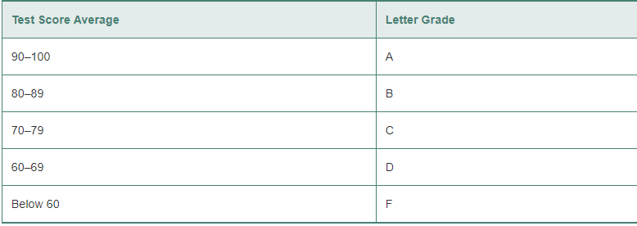

**#1 print screen the letter grade of (A) below here.**

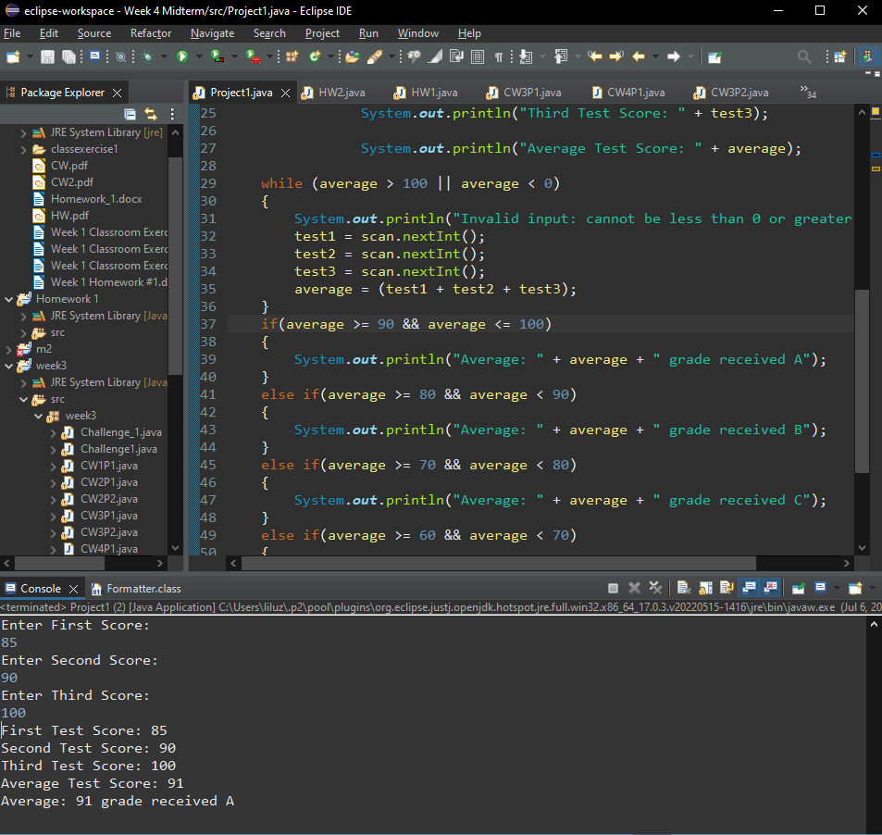

**#2 print screen the average grade over 100 below here.**

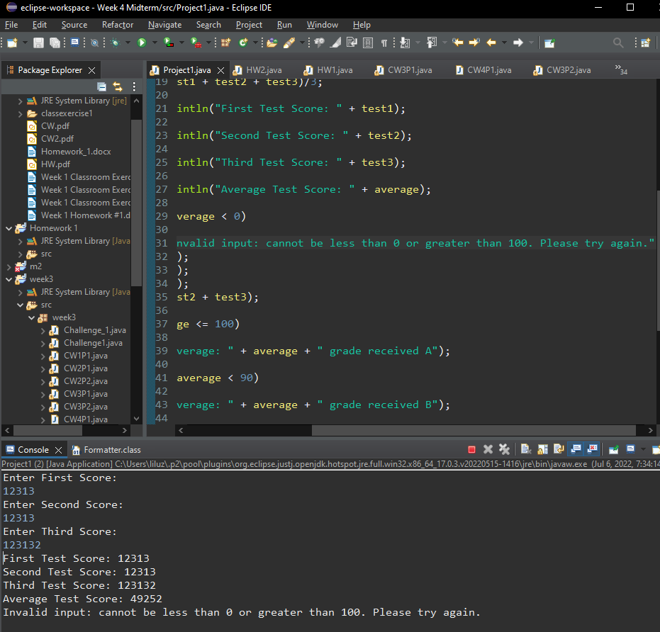

**#3 print screen the average grade of less than 0 below here.**

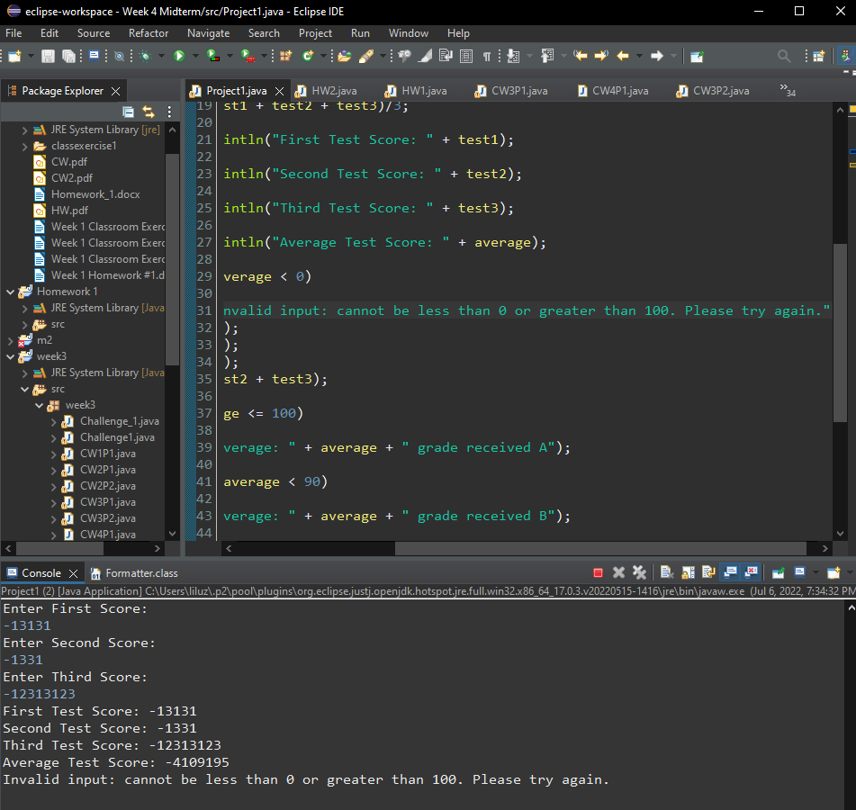

**Project #2**

**Based on Chapter 3 (Decision Making) & Chapter 04 (Loops)**

Convert Project #1 into a JOptionPane with input and message boxes.

**#4 print screen the letter grade of (A) below here.**

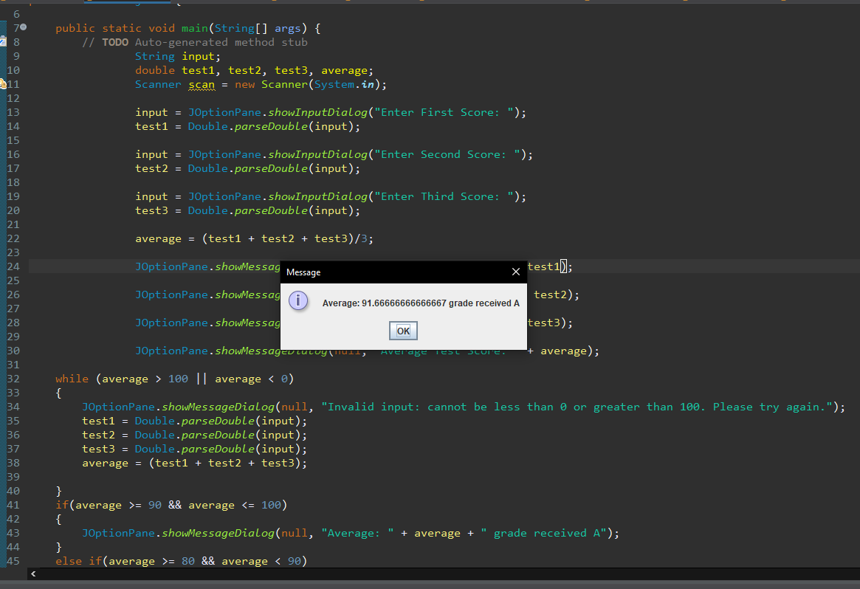

**#5 print screen the average grade over 100 below here.**

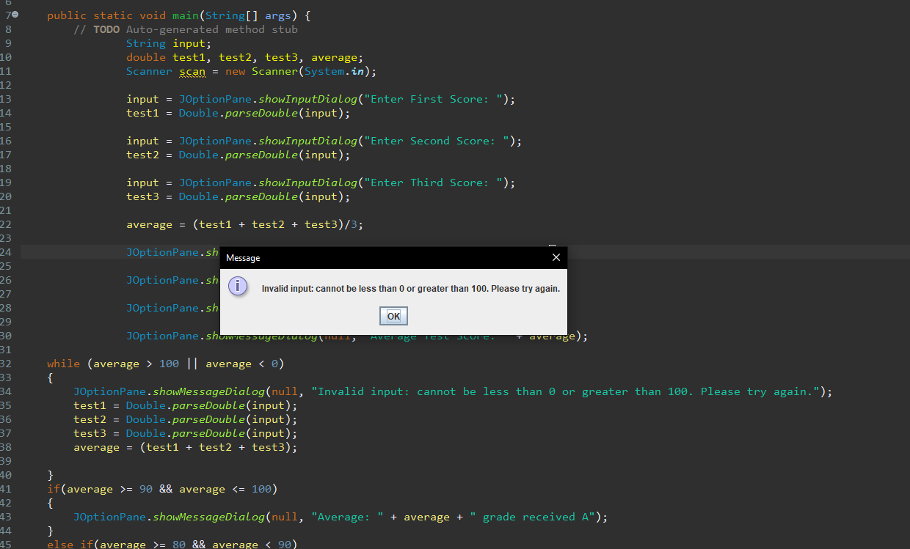

**#6 print screen the average grade of less than 0 below here.**

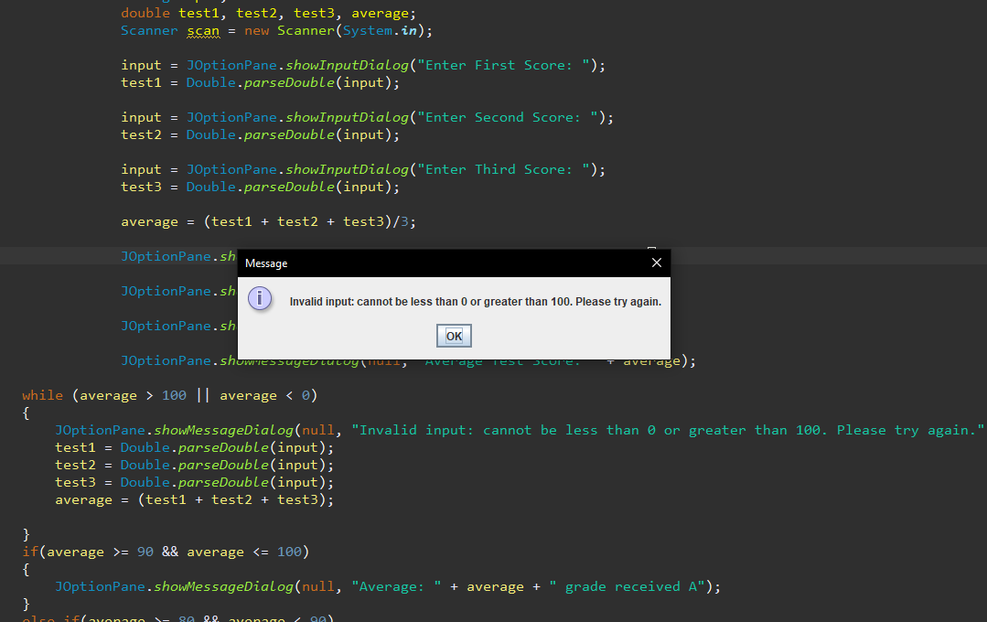

**Project #3**

**Based on Chapter 3 (Decision Making)**

Continuing from project #1, Ask the user to input the Last and First name and enter 3 scores (**use the test data as shown below**). After, get the total and average of the scores and **output it to a file** somewhere on your computer. Ensure to output the Last & First name with the sum and the average. Run the application 2x so it will **not overwrite** the first input.

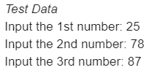

Output data (Please format the data output as shown below)

Welcome Doe, John: your total score is [**substitute the total score here**]

and your average score is [**substitute the average score here**]

**#7 print screen your results below here**

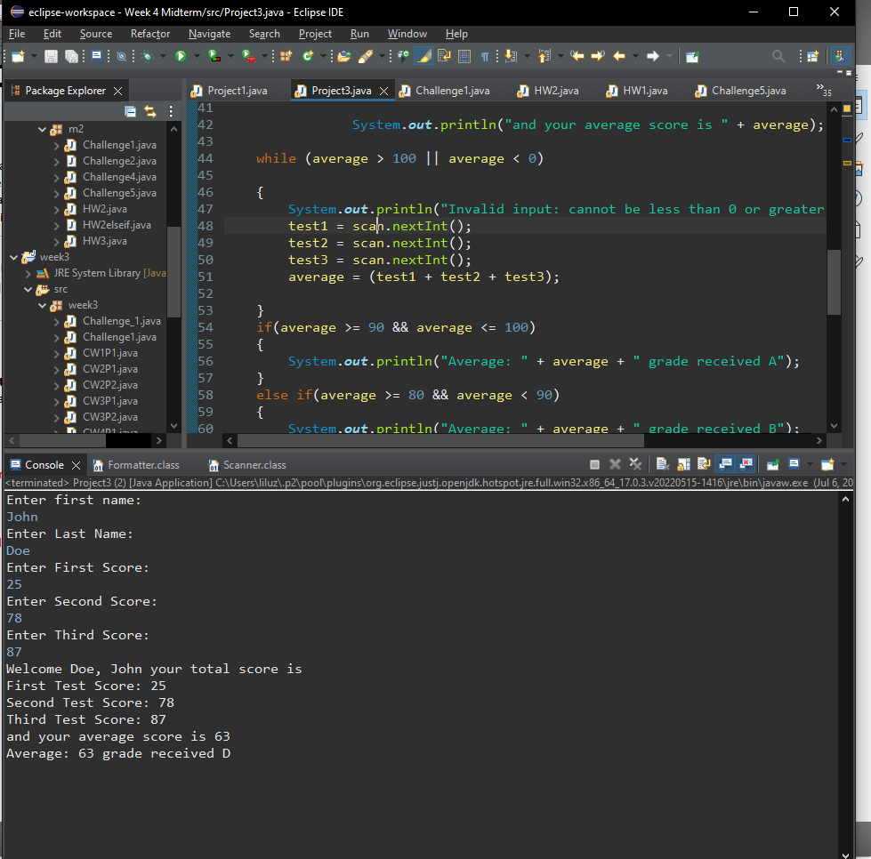

**#8 open your note pad or text file and print screen it below here**

**#9 print screen project #3 code below here**

import java.io.*;

import java.io.FileWriter;

import java.util.Scanner;

pu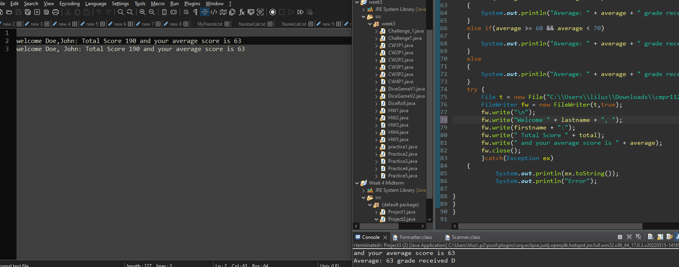blic class Project3 {

public static void main(String[] args) {

// **TODO** Auto-generated method stub

int test1, test2, test3, total, average;

String firstname, lastname;

Scanner scan = new Scanner(System.***in***);

System.***out***.println("Enter first name: ");

firstname = scan.nextLine();

System.***out***.println("Enter Last Name: ");

lastname = scan.nextLine();

System.***out***.println("Enter First Score: ");

test1 = scan.nextInt();

System.***out***.println("Enter Second Score: ");

test2 = scan.nextInt();

System.***out***.println("Enter Third Score: ");

test3 = scan.nextInt();

total = (test1 + test2 + test3);

average = (test1 + test2 + test3)/3;

System.***out***.println("Welcome " + lastname + ", " + firstname + " your total score is ");

System.***out***.println("First Test Score: " + test1);

System.***out***.println("Second Test Score: " + test2);

System.***out***.println("Third Test Score: " + test3);

System.***out***.println("and your average score is " + average);

while (average > 100 || average < 0)

{

System.***out***.println("Invalid input: cannot be less than 0 or greater than 100. Please try again.");

test1 = scan.nextInt();

test2 = scan.nextInt();

test3 = scan.nextInt();

average = (test1 + test2 + test3);

}

if(average >= 90 && average <= 100)

{

System.***out***.println("Average: " + average + " grade received A");

}

else if(average >= 80 && average < 90)

{

System.***out***.println("Average: " + average + " grade received B");

}

else if(average >= 70 && average < 80)

{

System.***out***.println("Average: " + average + " grade received C");

}

else if(average >= 60 && average < 70)

{

System.***out***.println("Average: " + average + " grade received D");

}

else

{

System.***out***.println("Average: " + average + " grade received F");

}

try {

File f = new File("C:\\Users\\liluz\\Downloads\\cmpr112 final\\scores.txt");

FileWriter fw = new FileWriter(f,true);

fw.write("\n");

fw.write("welcome " + lastname + ",");

fw.write(firstname + ":");

fw.write(" Total Score " + total);

fw.write(" and your average score is " + average);

fw.close();

}catch(Exception ex)

{

System.***out***.println(ex.toString());

System.***out***.println("Error");

}

}

}

**Project #4**

**Based on Chapter 4 (Loops)**

Write a for loop that will print **even** numbers for numbers 1-10

**#10 print screen the results with the code below here**

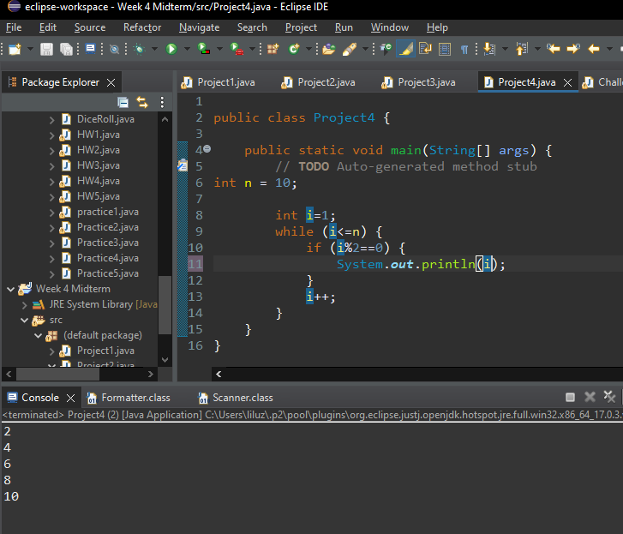

**Project #4 (A). Based on Chapter 4 (Loops)**

Write a for loop that will print **odd** numbers for numbers 1-10

**#11 print screen the results with the code below here**

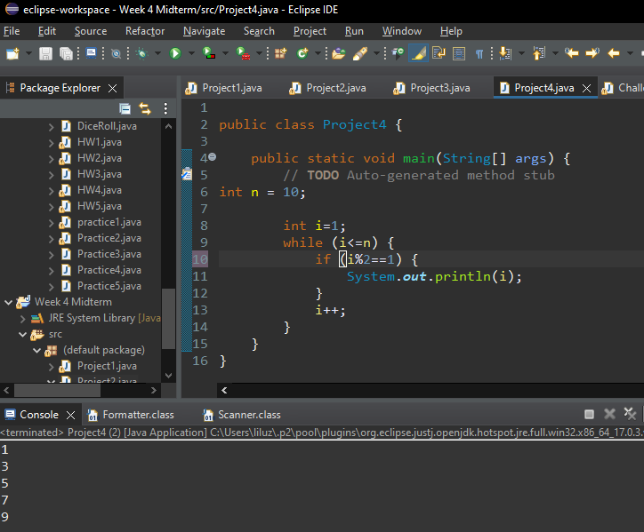

**Project #4 (B). Based on Chapter 4 (Loops)**

Using a While loop, display the following below

Note: be sure to write the characters Loop counter:

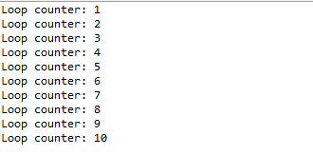

**#12 print screen the results with the code below here**

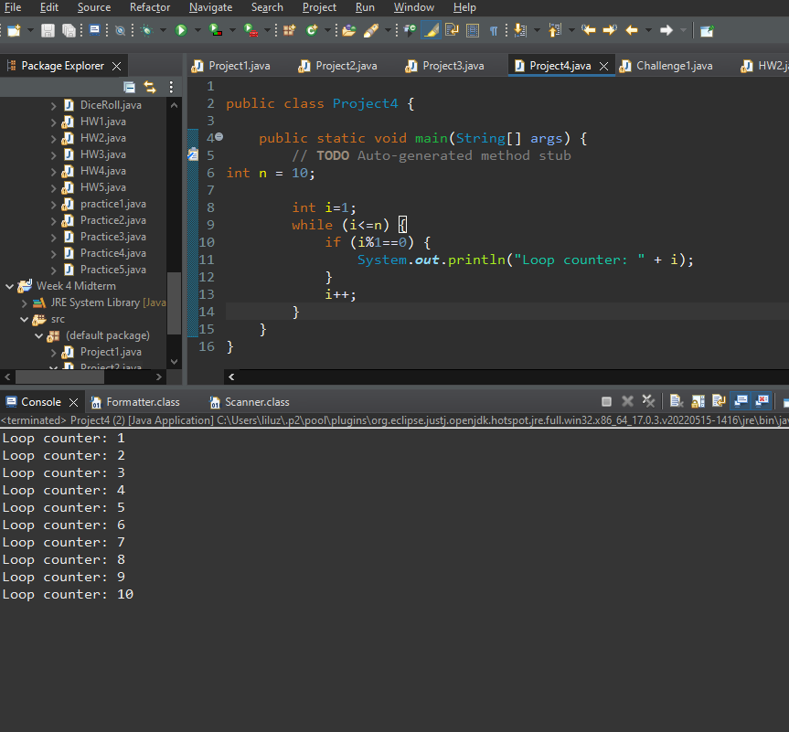

**Project #4 (C). Based on Chapter 4 (Loops)**

Using a **FOR** loop, display the following below

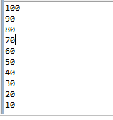

**#13 print screen the results with the code below here**

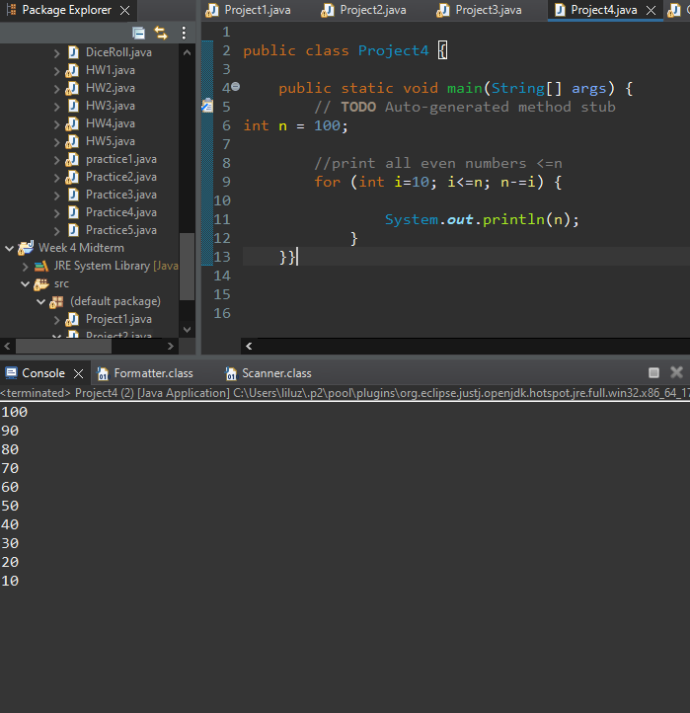

**Submit this document with the ZIPPED java midterm project to Module 4 midterm.**